A

MINI PROJECT ||

SYNOPSIS ON

‘’RESOURCE SHARING APPLICATION’’

BATCHLOR OF TECHNOLOGY

**‘**’COMPUTER SCIENCE AND ENGINEERING’’ SUBMITTED BY,

## TANISHK WAGH (2165451242081)

**OMKAR WAGH (2165451242072)**

## MANDAR SHINDE (2165451242069)

**PREETI RAJPURE (2165451242053)**

UNDER THE SUPERVISION OF,

## Mrs. Pharande R.S



**‘’ARVIND GAVLI COLLEGE OF ENGINEERING SATARA’’**

**2023-24**

# CERTIFICATE

This is to certify that the synopsis entitled “**RESOURCE SHARING APPLICATION**”

is a bonafide work carried out by,

MR. TANISHK WAGH .

MR. OMKAR WAGH.

MR. MANDAR SHINDE.

MS. PREETI RAJPURE.

under our supervision during the academic year 2023-24 and submitted to the faculty of Computer Science & Engineering, AGCE, Satara in partial fulfillment of the requirements for the final year of Bachelor of Technology in Computer Science & Engineering.

Mr. Aakash bhojane Mrs. Pharande .R.S

Alumni Mentor Guide

Mr. Pathak P.A Mrs .Varsha Bhosale

Project Co-Ordinator HOD

Dr. Mirajkar. G. S Dr. Pharande V. A.

Dean R & D Principal

(Internal Examiner) (External Examiner)

# TABLE OF CONTENTS

1. Introduction
2. Objectives and Scope of the Project
3. Literature Review
4. System Design
5. Hardware Required
6. Software Required
7. Estimation Of Project
8. Project Timeline
9. References

# Introduction:-

Students often face problem while collecting notes and it interrupts their learning process. Our application will provide a platform for the students where they can come together for collaborative learning. Students can share their notes/materials (both handwritten and in document - PPT, PDF, DOC, etc. format) to the admin of the website through the whatsapp or Email so the admin can check the notes and add then into the application and the students from any branch or semester from the different universities can access for free. In our platform users can upload their notes giving a short description and some keywords related to the subject, branch and semester. Other users can search the notes using those keywords which will provide them filtered results. Each user will have an account through they will access the application. The platform is planned to be a LEARN

| SHARE | EDUCATE platform which aims to increase effectiveness and conceptual clarity of students.

# Objectives and Scope Of The Project :-

* + **Objectives**

**Efficient Note-Taking**: Enable users to send their notes to admin and sot the admin can store their notes in various formats such as text, images, audio, and video, allowing them to capture information in the most suitable way.

**Organization**: Provide robust organizational features like folders, tags, and search functionalities to help users easily find and manage their notes, even as their collection grows.

**Collaboration**: Facilitate collaboration by allowing users to share their thoughts about the notes with the admin , either for viewing or editing, thus supporting teamwork and knowledge exchange.

**Accessibility**: Ensure accessibility across multiple devices and platforms, allowing users to access their notes anytime, anywhere, and from any device with an internet connection.

**Security**: Implement strong security measures to protect users' data, including secure authentication, and permission controls, to maintain the privacy and integrity of their notes.

**Feedback and Analytics**: Incorporate features for users to provide feedback and analytics to help them track their note-taking habits, identify patterns, and improve their productivity over time.

# Scope Of The Project

## Features and Functionalities:

User Registration and Authentication: Allow users to create accounts and authenticate securely.

Note Organization: Implement features like folders, tags, and search functionalities for efficient organization and retrieval of notes.

Sharing and Collaboration: Allow users to share notes with admin, specify permissions (view-only ).

Cross-Platform Accessibility: Ensure compatibility across various devices and platforms, including web browsers, mobile devices (iOS, Android), and desktop applications.

Synchronization: Implement synchronization mechanisms to ensure that notes are updated and consistent across all devices.

Security: Implement security measures like access controls to protect users' data and privacy.

# Literature Review

|  |  |  |  |  |
| --- | --- | --- | --- | --- |
| Sr.no | Author name | Paper name | Publication year | Technology used |
| 1 | John Smith et al | Notes taking tool | 2015 | In this application the python programming is used for making the application |
| 2 | Emily johnson | Notes sharing application | 2020 | This application is useful to the students who can't get study materials on the time |
| 3 | David brown | Notes sharing application | 2019 | This application can be made for the students for preparation of the exams |
| 4 | Rachel lee et al | Notes sharing application | 2020 | The working of this application project is based on the javascript and java technology |

**Gap Findings:**

Identifying gaps in a notes sharing application involves evaluating its current state against user expectations, industry standards, and competitor offerings. Here are some common areas where gaps might exist:

## User Experience (UX):

**Navigation:** If users find it difficult to navigate through the application or perform basic tasks like sharing notes, there could be a gap in the user experience.

**Responsiveness:** If the application is slow or unresponsive, especially during peak usage times or on mobile devices, it may lead to user frustration and dissatisfaction.

**Accessibility:** Lack of accessibility features such as keyboard navigation, screen reader compatibility, or adjustable font sizes could create barriers for users with disabilities.

## Performance and Scalability:

**Server Capacity:** If the application experiences frequent downtime or performance issues due to insufficient server capacity, it may disrupt user productivity and erode confidence in the service.

**Scalability:** Inadequate scalability may limit the application's ability to accommodate a growing user base or handle increased data loads, leading to degraded performance over time.

# System Design

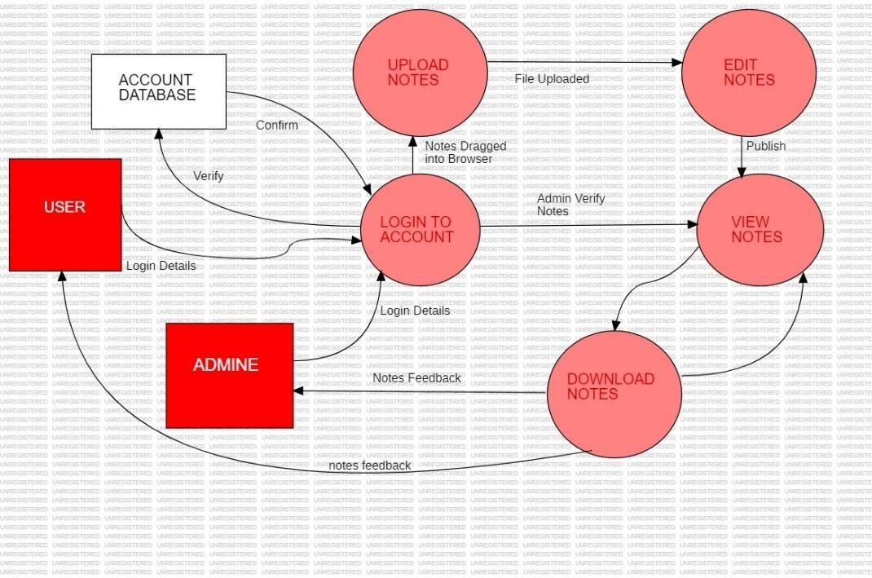

Component diagram

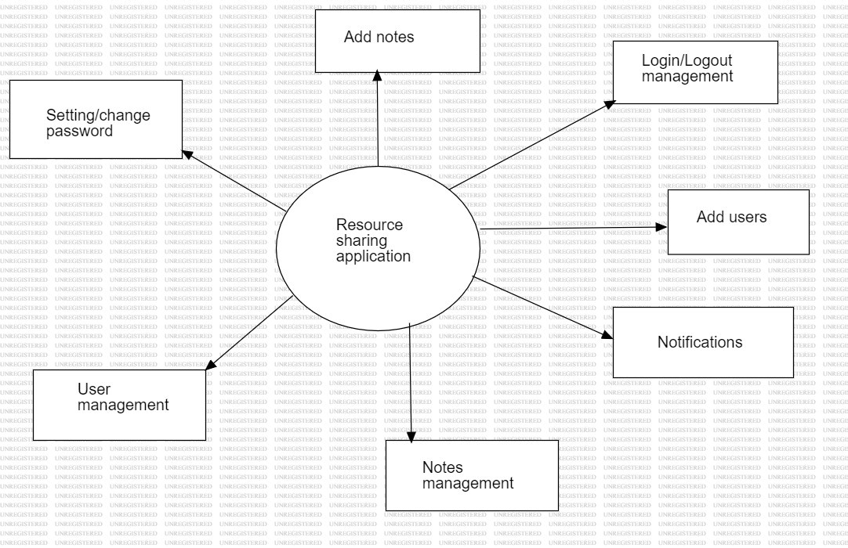

Zero level dfd

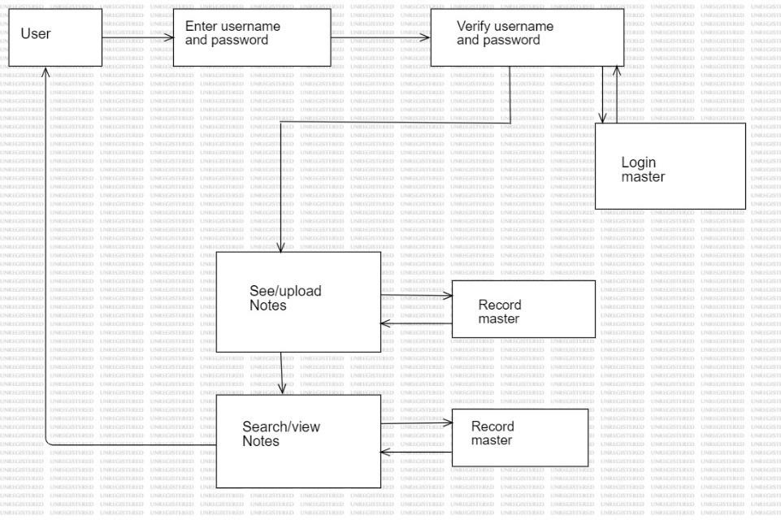

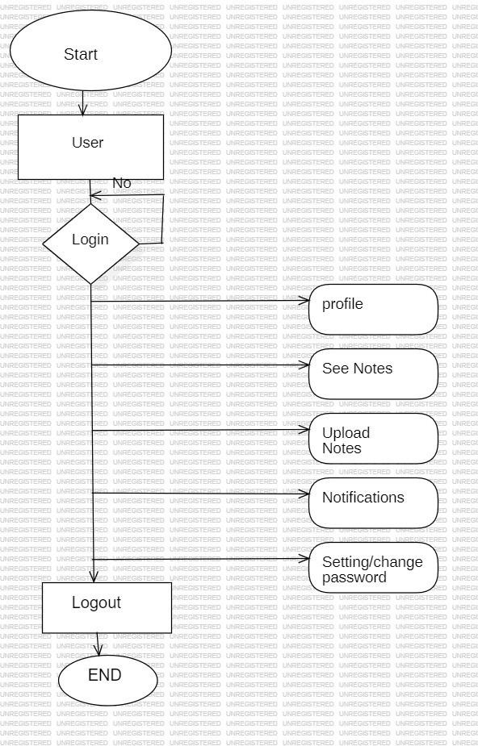

User side dfd

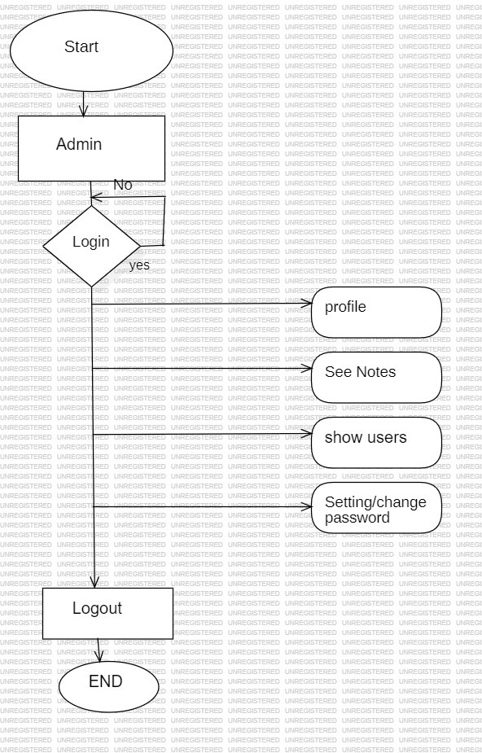

Admin side dfd

# Hardware Required

For a notes sharing application built using HTML, CSS, and PHP, the hardware requirements are relatively modest, as these technologies primarily run on the server-side and are not resource-intensive. However, the hardware specifications may vary based on factors such as expected traffic volume, database size, and additional features. Here's a basic outline of the hardware required:

## Server:

Processor: A multi-core processor (e.g., Intel Core i5 or equivalent) to handle simultaneous requests efficiently.

RAM: At least 2GB of RAM, although more may be required for larger applications or higher traffic volumes.

Storage: SSD storage for faster data access and improved application performance.

Operating System: Linux-based operating systems like Ubuntu or Debian are commonly used for hosting PHP applications due to their stability and compatibility with PHP.

## Networking:

Network Interface: A stable internet connection with sufficient bandwidth to handle incoming and outgoing traffic to the application.

Firewall: Implement firewall rules to protect the server from unauthorized access and potential security threats.

## Database Server:

If your application uses a database (e.g., MySQL, PostgreSQL), you'll need a separate server or instance to host the database.

Processor: Similar to the application server, a multi-core processor is recommended to handle database queries efficiently.

RAM: The amount of RAM required depends on the size of the database and the volume of concurrent database operations. At least 2GB of RAM is recommended for smaller databases.

Storage: SSD storage for the database server to ensure fast read/write operations and improved query performance.

## Backup Solution:

Implement a backup solution to regularly back up both the application and database data to prevent data loss in case of hardware failure or other unforeseen events.

## Development and Testing Environment:

While not directly related to production hardware, developers will require suitable hardware for development and testing purposes. This could include laptops or desktop computers with sufficient resources to run development environments, IDEs, and testing frameworks

# Software Requiredments :

For a notes sharing application developed using HTML, CSS, and PHP, you'll need a combination of software tools and technologies to build, deploy, and maintain the application. Below are the essential software requirements:

## Text Editor or Integrated Development Environment (IDE):

A text editor for writing and editing your HTML, CSS, and PHP code used is

## Visual Studio Code.

**Web Server:** A web server software to host and serve your PHP files used web servers for PHP development is **APACHE.**

## PHP Interpreter:

Install PHP on your development environment and server. You can download PHP from the official PHP website or use package managers like apt (for Linux) or Homebrew (for macOS).

**Database Management System (DBMS)**: A database management system to store and manage your application data, for PHP applications used for this system is MySQL

**Browser**: A web browser for testing and debugging your HTML, CSS, and JavaScript code. We used browsers for web development include Google Chrome, Mozilla Firefox and Microsoft Edge.

**Database Administration Tool**: A database administration tool to interact with our database, execute SQL queries, and manage database objects is phpMyAdmin (for MySQL).

# Estimation OF Project

|  |  |  |
| --- | --- | --- |
| Product | Unit | Price |
| XAMPP SERVER | 1 | - |
| VS-CODE | 1 | - |
| MYSQL Database | 1 | - |
| TOTAL | 3 | - |

# TimeLine

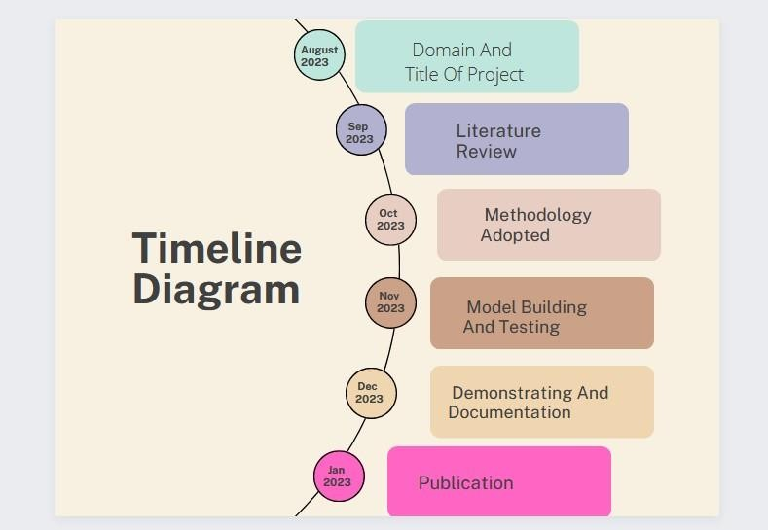

1. **References**

* IJRAMT_V3_I4_4-1.pdf
* [https://www.researchgate.net/publication/343464430_Notes_Sharing_Ap](https://www.researchgate.net/publication/343464430_Notes_Sharing_Application) [plication](https://www.researchgate.net/publication/343464430_Notes_Sharing_Application)
* <https://www.scribd.com/document/396271836/Report-Note-Sharing>
* [https://www.studocu.com/row/document/tribhuvanvishwavidalaya/csit/on](https://www.studocu.com/row/document/tribhuvanvishwavidalaya/csit/online-note-share-report-shiv-chaudhary/14511601) [line-note-share-report-shiv-chaudhary/14511601](https://www.studocu.com/row/document/tribhuvanvishwavidalaya/csit/online-note-share-report-shiv-chaudhary/14511601)